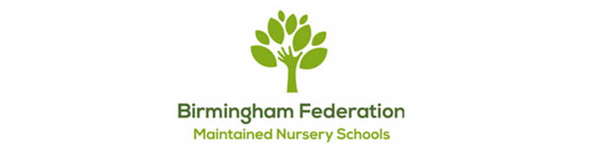

Become a Co-opted Governor with the Birmingham Federation of Maintained Nursery Schools
The Birmingham Federation of Maintained Nursery Schools (BFMNS) is looking for new Co-opted Governors to join our Governing Board and help shape the future of nine maintained nursery schools across South and Central Birmingham.
Our nine schools provide high-quality, inclusive early education and childcare to children and families from diverse communities across the city. Each school has its own distinctive identity and deep roots within its local community, while together they form one Federation with a shared commitment to ensuring that children flourish and thrive.

Could you bring your skills and experience to our Board?
Our Governing Board plays an important strategic role. Governors do not run our schools day-to-day; instead, they work collectively to provide strategic leadership, support and challenge, oversee educational outcomes and financial sustainability, and help ensure that our schools continue to provide the very best opportunities for Birmingham’s youngest children.
We are looking to strengthen our Board by recruiting people who can bring different experiences, perspectives and professional expertise to our work.
We would particularly welcome applicants with knowledge or experience in one or more of the following areas:
- strategic leadership, planning and organisational development;
- finance, business or commercial management;
- HR, employment and workforce development;
- safeguarding;
- property, buildings and estates;
- data, performance and digital development;
- early childhood, education or public services; and
- community engagement and partnership working.
You do not need to have worked in education or have previous experience as a governor. Skills developed in business, the public sector, voluntary and community organisations or through other professional and life experience can all make an important contribution.
Above all, we are looking for people who share our commitment to improving opportunities and outcomes for children and who are willing to contribute their experience, curiosity and independent thinking to our Board.

What is involved?
Being a Governor is a voluntary, non-executive role. Governors are expected to attend six Governing Board meetings each year, normally held in the late afternoon/early evening, alongside occasional school visits, training and other agreed activities.
New Governors receive an induction and have access to ongoing training and support. You will join a committed, multidisciplinary group of people who share a common purpose: helping our nine schools remain strong, sustainable and ambitious for the children and communities they serve.
We are particularly keen for our Governing Board to reflect the diversity of Birmingham and warmly welcome expressions of interest from people from all backgrounds.

Interested?
If you think your skills, experience and perspective could make a difference, we would be delighted to hear from you.
We welcome expressions of interest – please see attached form. Following an expression of interest, you will be invited to have an informal conversation with the Chair of Governors to find out more about the Federation, the role and what you could bring to our Governing Board.
Following that conversation, suitable prospective Governors who wish to take their interest further will be invited to complete the formal Birmingham City Council Governor application process.
An informal conversation is also very welcome before submitting an expression of interest. Please contact Selina Galsinh via email – s.galsinh@allenscn.bham.sch.uk to arrange. We recognise that people with valuable skills and experience may not previously have considered becoming a school governor, and we are happy to talk through what the role involves and answer any questions.
To find out more about the Birmingham Federation of Maintained Nursery Schools and our nine schools, visit www.bfmns.sch.life.

